A Supported Internship?  A supported Internship is a course offered throughout  England to young people in possession of an Education Health and Care Plan. What makes them different to other courses is that most of the learning is done at work,  ‘on the job’ | The Working Week  Each intern will spend four days a week in a work placement, gaining valuable skills and experience and one day a week at Peter Street Centre in St Helens, developing their English, Math’s and Employability Skills with a Job Coach and Employability Tutor | The Supported Internship Programme is a partnership between St Helens College and St Helens Council, aimed at giving young people, aged 16-25, the opportunity to gain valuable work experience, which will support aspirations towards future employment or voluntary work. | Supported Internships St Helens    
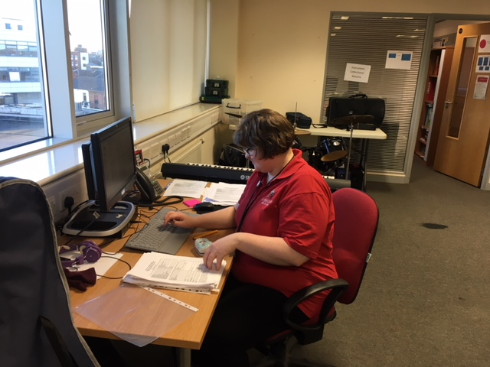  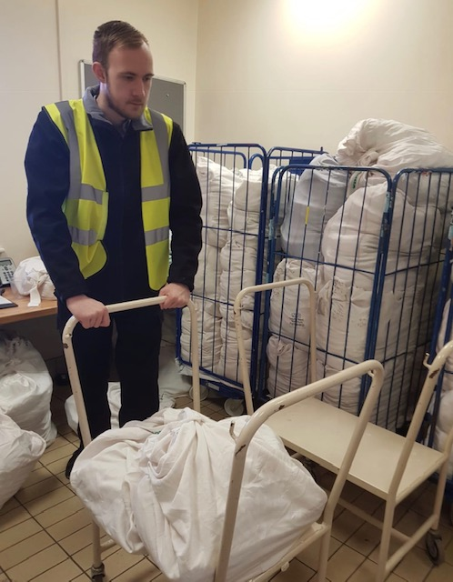 | How Long Does it Last?  The programme starts in September and runs over one academic year, giving interns the chance to experience a full-time work placement and demonstrate their ability in the role over a long term placement. |  | 
Contact:

Dawn Simm

DSimm@sthelens.ac.uk

01744 623358

07785 624 850

In order to find the right placement for the intern, the intern will complete a vocational profile. This will help us to determine the interns interests and preferences of work placement. It will document any past experiences of paid or voluntary work and also identify their strengths and abilities, in order to make a positive contribution in the workplace. It will highlight their support needs within the working environment and how these can be met. | Benefits of Supported Internships  Increased level of confidence and independence.  Ability to develop new skills within an active work environment.  The chance to make a really positive contribution.  Real experience to add to a CV.  Skills for the workplace.  Can result in paid employment at the end leading to financial independence  Meet new people and develop a wider social circle. | The Job Coach Will  • Support Internees to develop skills valued by employers  • Enable Internees to demonstrate their value in the workplace  • Develop confidence in their own abilities to perform successfully at work  The Job Coach will work closely with each intern and employer to ensure a smooth transition into their work placement and provide regular support throughout their programme. |  | 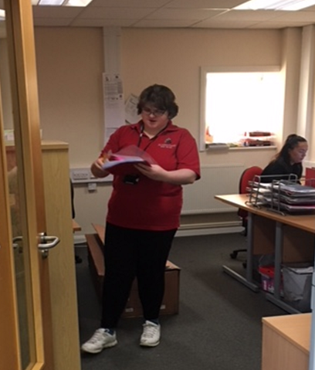
  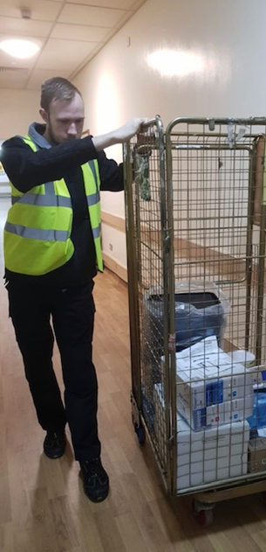 | Alongside their time at the employer, young people complete a personalised study programme one day a week studying both employability qualifications and English and maths at an appropriate level. They will also work with a Job Coach and Functional Skills tutor |  |  | The Mentor will help the intern to learn and understand their job role and if needed, they will meet the intern each morning on arrival and explain their daily tasks and duties.  As the role progresses and the interns get to know their role, this support may ease and may no longer be required.
 |  |  | What support will I receive during my internship?  Each intern will be assigned a Mentor in the work place. The Mentor will be the first point of contact if the intern needs any help or support or is experiencing any difficulties. | 

